**QUIZ MASTER**



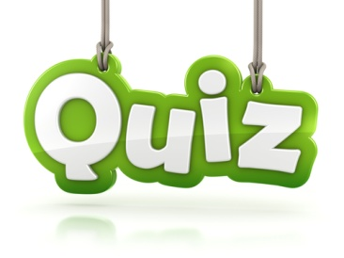



**MADE BY: SAHIL JADHAV & CHINMAY SINGOLE**

**CERTIFICATE**

CLASS: XII A YEAR: 2019-2020

THIS IS TO CERTIFY THAT INVESTIGATORY PROJECT IS SUCCESSFULLY COMPLETED BY _________________ OF CLASS _____ AND ROLL NO._________ FOR THE ACADEMIC YEAR 2019-2020 IN THE SCHOOL COMPUTER LAB

HEAD TEACHER EXTERNAL EXAMINER INTERNAL EXAMINER

SIGNATURE (SUBJECT TEACHER)

DATE: / / 20 DEPARTMENT OF COMPUTER SCIENCE

**ACKNOWLEDGEMENT**

WE __________________OF CLASS______ ROLLNO._________WOULD LIKE TO EXPRESS MY SINCERE GRATITUDE TO MY COMPUTER SCIENCE TEACHER MS. APARNA DHIRDE, PGT COMPUTER SCIENCE, FOR HER VITAL SUPPORT, GUIDANCE AND ENCOURAGEMENT—WITHOUT WHICH THIS PROJECT WOULD NOT HAVE COME FORTH.

I WOULD ALSO LIKE TO EXPRESS MY GRATITUDE TO MY SCHOOL KENDRIYA VIDYALAYA AMBARNATH FOR LETTING ME USE THE SCHOOL LABORATORY

# *INDEX*

* **BRIEF OVERVIEW OF PROJECT**
* **SOFTWARE AND HARDWARE REQUIREMENTS**
* **ADVANTAGES OF PROJECT**
* **SOURCE CODE IN PYTHON**
* **OUTPUT SCREEN**
* **BIBLIOGRAPHY**

# *Brief Overview OF Project*

*Quiz master is based on popular reality quiz shows where a player has to answer some questions based on various themes. The player gets to choose the correct answer from four different sets of options. If the player chooses the right option he gets one point and proceeds. If the option was wrong no points will be allotted.*

*Quiz Competitions are other events where similar mechanism is used. Programming language used for this projects are python and MySQL. Whole program is on python whereas database is stored on MySQL server database. Upon running the program, Player has to enter his/her name followed by starting the quiz. At the end total points scored by the player are shown. Similar mechanism can be seen in Quiz competitions too. Whether it be of school level or regional level.*

***Need Of Computerization***

*The use of computerized quizzes is highly recommended for any instructor teaching a course that is either large in size (with a typical lecture format) or that requires that students to engage in a significant amount of assigned readings. Students appear to benefit from the use of such computerized quizzes as they become actively engaged in the course material and study with greater frequency throughout the semester*

*Computerized settings can be designed to provide students with immediate feedback regarding their quiz grades, and allow them to take each quiz more than once to provide greater mastery of the material. It may be helpful to limit the number of quiz attempts to three.*

*Automatic, computerized grading and entry of each student’s highest quiz grades into the course gradebook will generate significant time savings for the instructor, and provide students with immediate feedback on their quiz performance.*

# *Software AND Hardware Requirements*

*#SOFTWARE SPECIFICATION*

*Operating System: Windows 10/8/7*

*Platform : Python IDLE 3.7/3.8*

*Database : MySQL*

*Languages : Python*

*#HARDWARE SPECIFICATION*

*Processor : Dual core or above*

*Hard Disk : 40 GB*

*RAM : 1024 MB*

# *Advantages OF Project*

*Present day everything is virtually presented.*

*Quiz master is very simple yet has attractive interface which makes quiz completions easier and more enjoyable.*

*Specific recommendations for the use of Quiz Master can be made including:*

* *To encourage students to engage in long-term learning, include some of the individual online quiz questions on midterm and final exams*
* *To deter student cheating, the order of quiz questions as well as their multiple choice answers is randomized.*
* *User friendly*
* *Responsive design*
* *Automatically checks answers*
* *It saves paper*
* *Publishes score instantaneously after quiz ends*

# #SOURCE CODE IN PYTHON

import sys

import mysql.connector

import random

mydb=mysql.connector.connect(host= "localhost" ,user= "root",\

passwd="root",database= "quiz")

mycursor=mydb.cursor()

def Home():

f=1

while f!=3:

print("Welcome to Quiz")

print("********************")

print("1. Enter Questions")

print("2. Take Quiz")

print("3. Exit")

f=int(input("Enter your choice: "))

if f==1:

Question()

elif f==2:

Quiz()

elif f==3:

print("Exiting the Quiz")

mycursor.close()

mydb.close()

sys.exit();

else:

Home()

def Question():

ch='Y'

while ch=='Y' or ch=='y':

print("Welcome to Question Portal")

print("***********************")

q=input("Enter the question :")

op1=input("Enter the option 1 :")

op2=input("Enter the option 2 :")

op3=input("Enter the option 3 :")

op4=input("Enter the option 4 :")

ans=0

while ans==0:

op=int(input("Which option is correct answer (1,2,3,4) :"))

if op==1:

ans=op1

elif op==2:

ans=op2

elif op==3:

ans=op3

elif op==4:

ans=op4

else:

print("Please choose the correct option as answer")

mycursor.execute("Select * from question")

data=mycursor.fetchall()

qid=(mycursor.rowcount)+1

mycursor.execute("Insert into question values (%s,%s,%s,%s,%s,%s,%s)",(qid,q,op1,op2,op3,op4,ans))

mydb.commit()

ch=input("Question added successfully.. Do you want to add more (Y/N)")

Home()

def Quiz():

print("Welcome to Quiz portal")

print("***********************")

mycursor.execute("Select * from question")

data=mycursor.fetchall()

name=input("Enter your name :")

rc=mycursor.rowcount

noq=int(input("Enter the number of questions to attempt (max %s):"%rc))

l=[]

while len(l)!=noq:

x=random.randint(1,rc)

if l.count(x)>0:

l.remove(x)

else:

l.append(x)

print("Quiz has started")

c=1

score=0

for i in range(0,len(l)):

mycursor.execute("Select * from question where qid=%s",(l[i],))

ques=mycursor.fetchone()

print("--------------------------------------------------------------------------------------------")

print("Q.",c,": ",ques[1],"\nA.",ques[2],"\t\tB.",ques[3],"\nC.",ques[4],"\t\tD.",ques[5])

print("--------------------------------------------------------------------------------------------")

c+=1

ans=None

while ans==None:

choice=input("Answer (A,B,C,D) :")

if choice=='A' or choice=='a':

ans=ques[2]

elif choice=='B' or choice=='b':

ans=ques[3]

elif choice=='C' or choice=='c':

ans=ques[4]

elif choice=='D' or choice=='d':

ans=ques[5]

else:

print("Kindly select A,B,C,D as option only")

if ans==ques[6]:

print("Correct")

score=score+1

else:

print("Incorrect.. Correct answer is :",ques[6])

print("Quiz has ended !! Your final score is :",score)

input("Press any key to continue")

Home()

Home()

# #OUTPUT SCREEN

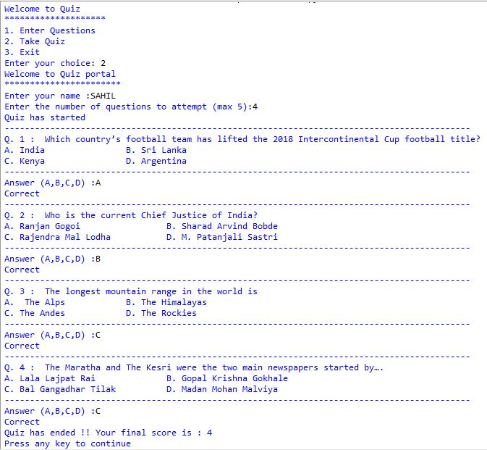

# #MYSQL TABLE

# C:\Users\Sahil\Desktop\quiz master.JPG

#LIMITATIONS

* Need to add questions first before playing quiz
* No permanent score board